Web Design and Development

4COSC011W

Coursework 1

Report

Author: Manula Haputhanthrie

Student ID: 20191046

Group Number: E2

Student Role: 1

Link(s) to WebSite

URL:

<https://w1790305.users.ecs.westminster.ac.uk/Web-Cwk/presentation.html>

Content **Error! Bookmark not defined.**

1. Introduction 3

2. Technical Discussion 3

• Presentation Page 3

• Main Page **Error! Bookmark not defined.**

• Font size change 3

• Comments Form **Error! Bookmark not defined.**

• Buy products **Error! Bookmark not defined.**

• Quiz **Error! Bookmark not defined.**

• View images and change text/background colour **Error! Bookmark not defined.**

3. Discussion of UI and application of UX principles 13

3.1 Information architecture 13

a. Design 13

b. Code to achieve good Information architecture **Error! Bookmark not defined.**

3.2 Colour balance/composition/graphics/consistency 14

a. Design 14

b. Code to achieve good colour balance & ensure consistency 14

c. Colour contrast test results 14

3.3 Typography / consistency 29

a. Design 29

b. Code to achieve good typography / consistency 29

3.4 Gestalt principles grouping 29

3.5 Accessibility (graphics/forms) **Error! Bookmark not defined.**

a. Graphical elements - Design/Code **Error! Bookmark not defined.**

b. Form completion - Design/Code **Error! Bookmark not defined.**

3.6 Error prevention and recovery **Error! Bookmark not defined.**

a. Design **Error! Bookmark not defined.**

b. Code to address error prevention and recovery **Error! Bookmark not defined.**

4 Janet 31

5 Conclusions 31

References 31

Appendices 31

Appendix A: Code 31

Appendix B: Screenshots 59

Appendix C: Individual Statement 60

# Introduction

This Coursework is a group coursework of 4 students who have been assigned individual tasks. Our group members and their tasks are as follows.

1. Manula Haputhanthrie - 20191046 - Student 1
2. Ravindu Kodithuwakku - 20191039 - Student 2
3. Tharuka Jayasooriya - 20191049 - Student 3
4. Shinoli Perera - 20191081 - Student 4

Cricket is the topic of our website. We named our website name as “cricketWorld”.

# Technical Discussion

I was allocated to do the student 1 role and my tasks were listed below.

## Presentation Page

## Font size change

## Buy products

Also I created the Information page(History of Cricket) and the developer’s page.

Presentation Page :

First page of our website is this presentation page. It contain our group members’ information and it will redirect to our website’s main page after five seconds. The javascript code for the timeout function is given below.

<script>

setTimeout(function(){

window.location.href ="home.html";

}, 5000);

</script>

Shopping Cart Page :

In this page, there are shopping items, shopping cart, form and font size changer. There are 9 products to chose from. When Add to Cart button clicked the image, name and the price of the products will be displayed in the cart section Also there is a function that can increase each product’ quantity. The Remove button can remove the respective item from the cart. The Total price for the selected items is calculate when adding items to the cart.

The Javascript code for this is given below.

if (document.readyState == 'loading') {

document.addEventListener('DOMContentLoaded', ready)

} else {

ready()

}

function ready() {

var removeCartItemButtons = document.getElementsByClassName('btn-rmve')

for (var i = 0; i < removeCartItemButtons.length; i++) {

var button = removeCartItemButtons[i]

button.addEventListener('click', removeCartItem)

}

var Inputs = document.getElementsByClassName('quantity-input')

for (var i = 0; i < Inputs.length; i++) {

var input = Inputs[i]

input.addEventListener('change', quantityChanged)

}

var addToCartButtons = document.getElementsByClassName('item-button')

for (var i = 0; i < addToCartButtons.length; i++) {

var button = addToCartButtons[i]

button.addEventListener('click', addToCartClicked)

}

}

function removeCartItem(event) {

var buttonClicked = event.target

buttonClicked.parentElement.parentElement.remove()

updateCartTotal()

}

function quantityChanged(event) {

var input = event.target

if (isNaN(input.value) || input.value <= 0) {

input.value = 1

}

updateCartTotal()

}

function addToCartClicked(event) {

var button = event.target

var shopItem = button.parentElement.parentElement

var title = shopItem.getElementsByClassName('item-title')[0].innerText

var price = shopItem.getElementsByClassName('item-price')[0].innerText

var imageSrc = shopItem.getElementsByClassName('item-image')[0].src

addItemToCart(title, price, imageSrc)

updateCartTotal()

}

function addItemToCart(title, price, imageSrc) {

var cartRow = document.createElement('div')

cartRow.classList.add('cart-row')

var cartItems = document.getElementsByClassName('cart-items')[0]

var cartItemNames = cartItems.getElementsByClassName('cart-item-title')

for (var i = 0; i < cartItemNames.length; i++) {

if (cartItemNames[i].innerText == title) {

alert('Already added to the cart')

return

}

}

var cartRowContents = `

<div class="cart-item cart-column">

<img class="cart-item-image" src="${imageSrc}" width="100" height="100">

<span class="cart-item-title">${title}</span>

</div>

<span class="cart-price cart-column">${price}</span>

<div class="cart-quantity cart-column">

<input class="quantity-input" type="number" value="1">

<button class="btn btn-rmve" type="button">Remove</button>

</div>`

cartRow.innerHTML = cartRowContents

cartItems.append(cartRow)

cartRow.getElementsByClassName('btn-rmve')[0].addEventListener('click', removeCartItem)

cartRow.getElementsByClassName('quantity-input')[0].addEventListener('change', quantityChanged)

}

function updateCartTotal() {

var cartItemContainer = document.getElementsByClassName('cart-items')[0]

var cartRows = cartItemContainer.getElementsByClassName('cart-row')

var total = 0

for (var i = 0; i < cartRows.length; i++) {

var cartRow = cartRows[i]

var priceElement = cartRow.getElementsByClassName('cart-price')[0]

var quantityElement = cartRow.getElementsByClassName('quantity-input')[0]

var price = parseFloat(priceElement.innerText.replace('$', ''))

var quantity = quantityElement.value

total = total + (price * quantity)

}

total = Math.round(total * 100) / 100

document.getElementsByClassName('cart-total-price')[0].innerText = '$' + total

}

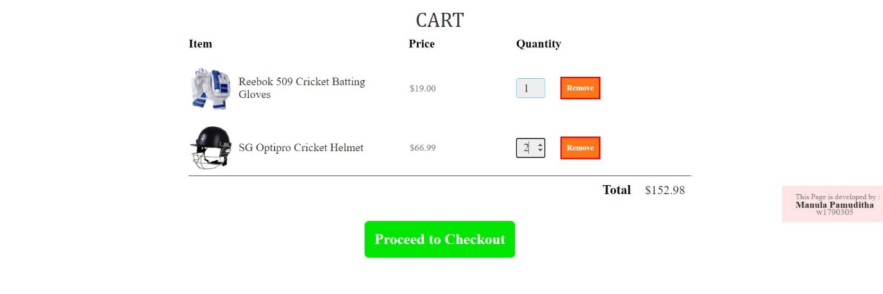

Javascript code for font size changing:

function increaseFontSize()

{

txt = document.getElementById('text');

style = window.getComputedStyle(txt, null).getPropertyValue('font-size');

currentSize = parseFloat(style);

txt.style.fontSize = (currentSize + 1) + 'px';

txt = document.getElementById('head');

style = window.getComputedStyle(txt, null).getPropertyValue('font-size');

currentSize = parseFloat(style);

txt.style.fontSize = (currentSize + 1) + 'px';

txt = document.getElementById('info');

style = window.getComputedStyle(txt, null).getPropertyValue('font-size');

currentSize = parseFloat(style);

txt.style.fontSize = (currentSize + 1) + 'px';

txt = document.getElementById('title');

style = window.getComputedStyle(txt, null).getPropertyValue('font-size');

currentSize = parseFloat(style);

txt.style.fontSize = (currentSize + 1) + 'px';

txt = document.getElementById('crt');

style = window.getComputedStyle(txt, null).getPropertyValue('font-size');

currentSize = parseFloat(style);

txt.style.fontSize = (currentSize + 1) + 'px';

txt = document.getElementById('itm');

style = window.getComputedStyle(txt, null).getPropertyValue('font-size');

currentSize = parseFloat(style);

txt.style.fontSize = (currentSize + 1) + 'px';

txt = document.getElementById('prc');

style = window.getComputedStyle(txt, null).getPropertyValue('font-size');

currentSize = parseFloat(style);

txt.style.fontSize = (currentSize + 1) + 'px';

txt = document.getElementById('qun');

style = window.getComputedStyle(txt, null).getPropertyValue('font-size');

currentSize = parseFloat(style);

txt.style.fontSize = (currentSize + 1) + 'px';

txt = document.getElementById('totl');

style = window.getComputedStyle(txt, null).getPropertyValue('font-size');

currentSize = parseFloat(style);

txt.style.fontSize = (currentSize + 1) + 'px';

txt = document.getElementById('price');

style = window.getComputedStyle(txt, null).getPropertyValue('font-size');

currentSize = parseFloat(style);

txt.style.fontSize = (currentSize + 1) + 'px';

}

function decreaseFontSize()

{

txt = document.getElementById('text');

style = window.getComputedStyle(txt, null).getPropertyValue('font-size');

currentSize = parseFloat(style);

txt.style.fontSize = (currentSize - 1) + 'px';

txt = document.getElementById('head');

style = window.getComputedStyle(txt, null).getPropertyValue('font-size');

currentSize = parseFloat(style);

txt.style.fontSize = (currentSize - 1) + 'px';

txt = document.getElementById('info');

style = window.getComputedStyle(txt, null).getPropertyValue('font-size');

currentSize = parseFloat(style);

txt.style.fontSize = (currentSize - 1) + 'px';

txt = document.getElementById('title');

style = window.getComputedStyle(txt, null).getPropertyValue('font-size');

currentSize = parseFloat(style);

txt.style.fontSize = (currentSize - 1) + 'px';

txt = document.getElementById('crt');

style = window.getComputedStyle(txt, null).getPropertyValue('font-size');

currentSize = parseFloat(style);

txt.style.fontSize = (currentSize - 1) + 'px';

txt = document.getElementById('itm');

style = window.getComputedStyle(txt, null).getPropertyValue('font-size');

currentSize = parseFloat(style);

txt.style.fontSize = (currentSize - 1) + 'px';

txt = document.getElementById('prc');

style = window.getComputedStyle(txt, null).getPropertyValue('font-size');

currentSize = parseFloat(style);

txt.style.fontSize = (currentSize - 1) + 'px';

txt = document.getElementById('qun');

style = window.getComputedStyle(txt, null).getPropertyValue('font-size');

currentSize = parseFloat(style);

txt.style.fontSize = (currentSize - 1) + 'px';

txt = document.getElementById('totl');

style = window.getComputedStyle(txt, null).getPropertyValue('font-size');

currentSize = parseFloat(style);

txt.style.fontSize = (currentSize - 1) + 'px';

txt = document.getElementById('price');

style = window.getComputedStyle(txt, null).getPropertyValue('font-size');

currentSize = parseFloat(style);

txt.style.fontSize = (currentSize - 1) + 'px';

}

Javascript code for overlay window:

function on() {

document.getElementById("overlay").style.display = "block";

}

function off() {

var a=document.getElementsByClassName("overlay-text");

var n;

for (n = 0; n < a.length; ++n) {

a[n].value="";

}

document.getElementById("overlay").style.display = "none";

}

Javscript Code for Validation :

function validation(){

var fname = document.getElementById("fname").value;

var lname = document.getElementById("lname").value;

var email = document.getElementById("email").value;

var cntact = document.getElementById("cntact").value;

var address = document.getElementById("address").value;

var ppl = document.getElementById("ppl").checked;

var crc = document.getElementById("crc").checked;

var dbc = document.getElementById("dbc").checked;

var crdhld = document.getElementById("crdhld").value;

var crdnum = document.getElementById("crdnum").value;

if(fname=="null" || fname=="" ){

alert("Please Provide Your First Name!");

}

else if(lname=="null" || lname==""){

alert("Please Provide Your Last Name!");

}

else if(email=="null" || email==""){

alert("Please Provide the email address!");

}

else if(email.length < 8 || email.indexOf("@") == -1 || email.indexOf(".") == -1){

alert("You have entered an invalid email address");

}

else if(cntact=="null" || cntact==""){

alert("Please Provide a phone number!");

}

else if(cntact.length != 10){

alert("You have entered an invalid phone number");

}

else if(address=="null" || address==""){

alert("Please Provide your address!");

}

else if(address.indexOf(",") == -1 || address.length < 7){

alert("You have entered an invalid address");

}

else if(ppl=="" && crc=="" && dbc ==""){

alert("Please select a payment method");

}

else if(crdhld=="null" || crdhld==""){

alert("Please provide the card holder's name!!");

}

else if(crdnum=="null" || crdnum==""){

alert("Please provide the card number!!");

}

else{

alert("Dear " +fname+lname+ ", Your order has been requested successfully!! You will recieve an confirmation email to " +email+ " shortly.\n\n\n Thank You for shopping with us!!" );

}

}

# Discussion of UI and application of UX principles

## 3.1 Information architecture

### a. Design

I used Section tags and div tags to make the structure of my web pages. There is the navigation bar in the top of my pages and also have a footer in bottom of the pages.

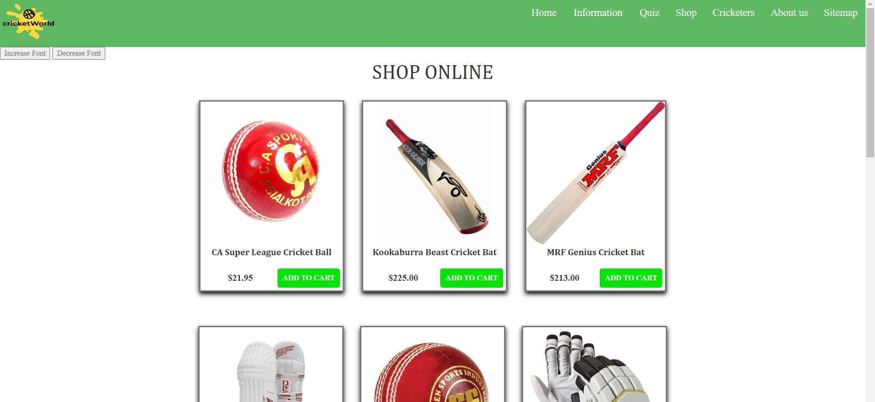

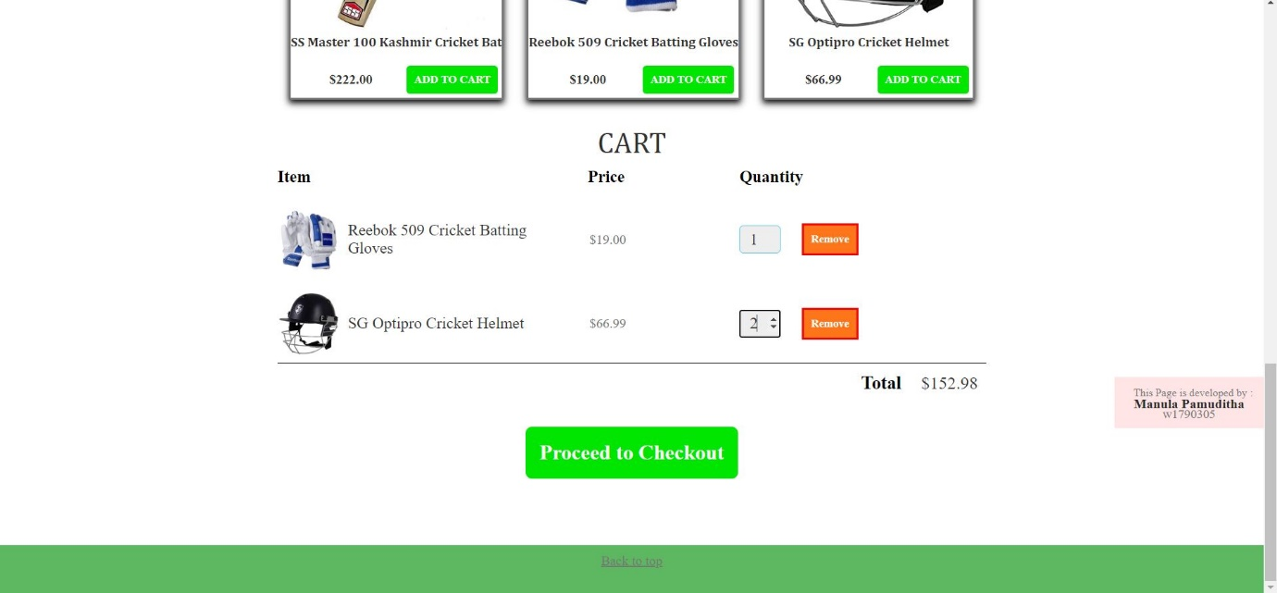

## 3.2 Colour balance/composition/graphics/consistency

### a. Design

### b. Code to achieve good colour balance & ensure consistency

My CSS code for the shopping cart page:

@font-family{

font-family:Cambria;

}

* {

box-sizing: border-box;

font-family: item-title;

color: #777;

}

html, body {

margin: 0;

padding: 0;

min-height: 100%;

}

.container {

max-width: 900px;

margin: 0 auto;

padding: 0 1.5em;

}

.section-header {

font-family: Cambria;

font-weight: normal;

color: #333;

text-align: center;

}

#title {

font-size:35px;

}

#crt {

font-size:35px;

}

.btn {

text-align: center;

vertical-align: middle;

padding: .67em .67em;

cursor: pointer;

}

.btn-primary {

color: white;

background-color:#00e600;

border: none;

border-radius: .3em;

font-weight: bold;

}

.btn-primary:hover {

background-color:#00b300;

}

.item {

margin-left: 10px;

margin-right: 10px;

margin-top: 30px;

margin-bottom: 30px;

border-color:#900;

border:solid;

box-shadow: 0 4px 8px 0 rgb(0, 0, 0);

}

#text{

font-size:16px;

}

.item-title {

display: block;

width: 100%;

text-align: center;

font-weight: bold;

font-size: 1.0em;

color: #333;

margin-bottom: 15px;

font-family:Cambria;

}

.item-image {

height: 250px;

}

.item-details {

display: flex;

align-items: center;

padding: 5px;

text-align:center;

}

.item-price {

flex-grow: 1;

color: #333;

font-weight:bold;

}

.items {

display: flex;

flex-wrap: wrap;

justify-content: space-around;

}

.cart-header {

color: #000;

font-weight: bold;

}

#itm {

font-size:20px;

}

#prc {

font-size:20px;

}

#qun {

font-size:20px;

}

.cart-column {

display: flex;

align-items: center;

margin-right: 1.5em;

padding-bottom: 10px;

margin-top: 10px;

}

.cart-row {

display: flex;

}

.cart-item {

width: 45%;

}

.cart-quantity {

width: 35%;

}

.cart-price {

width: 20%;

}

.cart-item-title {

color: #333;

margin-left: .5em;

font-size: 1.2em;

}

.cart-item-image {

width: 75px;

height: auto;

border-radius: 10px;

}

.btn-rmve {

color: white;

background-color: #ff751a;

border:solid;

border-color:red;

font-weight: bold;

}

.btn-rmve:hover {

background-color:#e65c00;

}

.quantity-input {

height: 34px;

width: 50px;

border-radius: 5px;

border: 1px solid #56CCF2;

background-color: #eee;

color: #333;

padding: 0;

text-align: center;

font-size: 1.2em;

margin-right: 25px;

}

.cart-row:last-child {

border-bottom: 1px solid black;

}

.cart-row:last-child .cart-column {

border: none;

}

.cart-total {

text-align: end;

margin-top: 10px;

margin-right: 10px;

}

.cart-total-title {

font-weight: bold;

color: black;

margin-right: 20px;

}

#totl {

font-size:22px;

}

.cart-total-price {

color: #333;

}

#price {

font-size:21px;

}

.btn-proceed {

display: block;

margin: 40px auto 80px auto;

font-size:25px;

}

label {

margin-left: 10px;

display: inline-block;

}

input[type=submit] {

border: 2px solid black;

}

.radio{

display:flex;

position:relative;

}

#overlay {

position: fixed;

display: none;

width: 70%;

height: 95%;

top: 0;

left: 0;

right: 0;

bottom: 0;

background-color:#ffe6e6;

z-index: 2;

cursor: pointer;

opacity: 1;

margin: auto;

border:solid;

}

#content{

padding-top:10px;

padding-bottom:10px;

padding-left:100px;

padding-right:100px;

}

.overlay-label

{

font-size:15px;

font-family:Cambria;

color:#000;

margin:2px 60px;

padding:12px 20px;

}

.overlay-text

{

width: 50%;

padding:12px 20px;

margin: 2px 60px;

border: 1px solid #ccc;

border-radius: 4px;

box-sizing: border-box;

float:right;

text-align:left;

display:inline-block;

color:#000;

}

.ovrl-butn{

background-color: #44cc00 ;

border:solid;

color:#FFF;

padding: 7px 14px;

width:100px;

margin: 28px 14px;

cursor: pointer;

border-color:#F00;

}

.frmbutn:hover {

background-color:#4CAF50 ;

}

.footer {

grid-area: footer;

background-color: #4caf50e6;

padding: 10px;

text-align: center;

height:60px;

}

.devlpr{

top: 227%;

position:absolute;

right: 0;

line-height: 0.6;

background-color:#ffe6e6;

padding: 13px;

}

.devlpr label{

font-size:13px;

line-height:0.8;

}

.devlpr span{

font-size:15px;

}

.devlpr h4{

color: #292929;

line-height: 0.9;

}

.devlpr a{

text-decoration: none;

color: #292929;

}

### c. Colour contrast test results

For the Main Background:

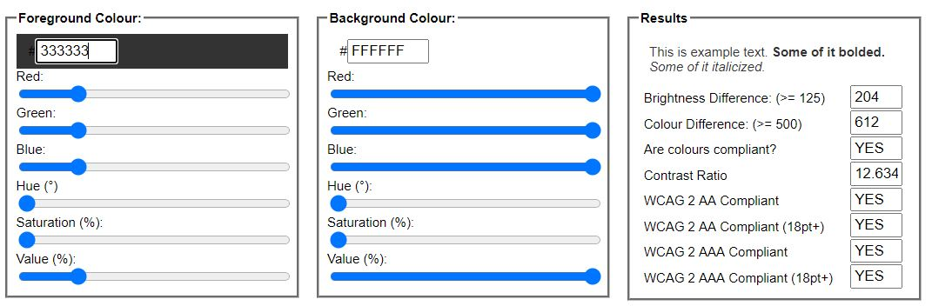

For the header and footer:

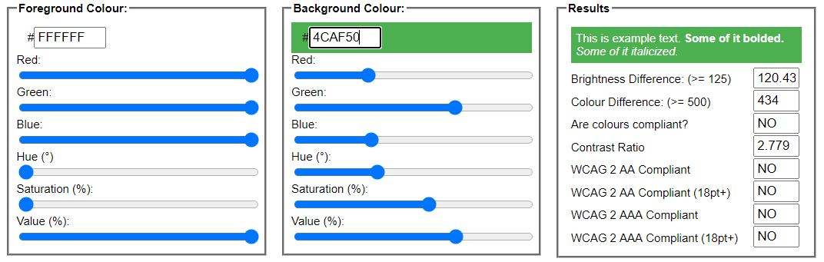

For the Overlay:

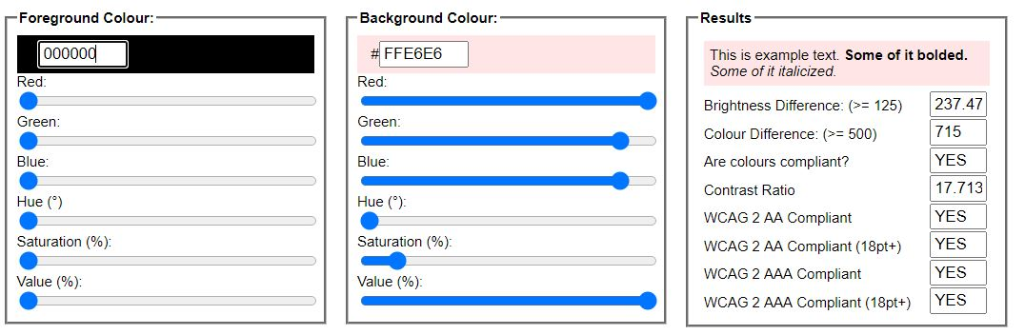

## Typography / consistency

### a. Design

Section guidelines: Explain the fonts, font sizes, colours and styles you used to ensure the proposed web site is appealing and suitable for its purpose and at the same time legible. Explain how you ensured content relevance and consistency (e.g. paragraph titles, subtitles, text, small font).

### b. Code to achieve good typography / consistency

Section guidelines:

* What CSS you created to modify text.
* Did you use any of the online tools to test the legibility of your web site? What were the test results?
* How did you write the CSS to ensure consistency?

-----------------------------------------------------------------------------------------------------------------

## Gestalt principles grouping





When I click the Add to cart button of a item , the item will added to the cart.

# Janet

We used all the images of our team members under each other’s permission.

All our group members are responsible for the content of our website. The website does not contain any outside services from which unsolicited commercial or advertising material or similar activities or any obscene materials are displayed.

# Conclusions

This was a whole new experience for me to create a fully functional website with our team members. I implemented the codes for web pages with the help of lectures, lecture notes, youtube tutorial videos and websites like w3schools,stackoverflow etc. There were some difficulties when I creating web pages, then I searched from the google and solved those problems. By referring to w3schools I solved lot of problems with my codes.

Also there were some problem in latter stages when linking all the web pages and hosting the web site, but we managed to solve those. And also I think I have to improve more with web designing skills to make better website in future.

# References :

<https://www.w3schools.com/js/>

<https://javascript.info/>

<https://www.youtube.com/watch?v=YeFzkC2awTM>

<https://www.youtube.com/watch?v=023Psne_-_4>

<https://en.wikipedia.org/wiki/History_of_cricket#:~:text=Having%20originated%20in%20south%2Deast,%2C%20retrospectively%20recognised%2C%20in%201877.>

<http://www.cricketlab.co/cricket-history>

# Appendices

## Appendix A: Code

File name : Presentation Page

HTML Code :

<!doctype html>

<html lang="en">

<head>

<title>Presentation Page</title>

<meta charset="UTF-8">

<meta name="viewport" content="width=device-width, initial-scale=1.0">

<link rel="stylesheet" type="text/css" href="attach/presentation.css" />

<script>

setTimeout(function(){

window.location.href ="home.html";

}, 5000);

</script>

</head>

<body background="img/bgnew.jpg">

<h1 ><b>Welcome to the Cricket World !!!</b></h1>

<h2><b>Our Team</b></h2>

<div id="stu1">

<img src="img/manula.jpg" alt="manula" height="265px" width="260px">

<h3><b>Manula Pamuditha</b></h3>

<p id="id"><b>IIT ID No : 20191046</b></p>

<p id="id"><b>UOW ID No: w1790305</b></p>

</div>

<div id="stu2">

<img src="img/ransi.jpeg" alt="ransara" height="265px" width="260px">

<h3><b>Ravindu Ransara</b></h3>

<p id="id"><b>IIT ID No : 20191039</b></p>

<p id="id"><b>UOW ID No: w1790300</b></p>

</div>

<div id="stu3">

<img src="img/tharuka.jpeg" alt="tharuka" height="265px" width="260px">

<h3><b>Tharuka Jayasooriya</b></h3>

<p id="id"><b>IIT ID No : 20191049</b></p>

<p id="id"><b>UoW ID No : w1789998</b></p>

</div>

<div id="stu4">

<img src="img/shinoli.jpeg" alt="shinoli" height="265px" width="260px">

<h3><b>Shinoli Perera</b></h3>

<p id="id"><b>IIT ID No : 20191081</b></p>

<p id="id"><b>UOW ID No : w1790003</b></p>

</div>

<div class="devlpr">

<label>This Page is developed by</label>

<h4><a href="mydetails.html">Manula Pamuditha</a></h4>

<span>w1790305</span>

</div>

<body>

</html>

CSS Code :

h1{

font-size:50px;

text-align: center;

font-family:Comic Sans MS, cursive, sans-serif;

}

h2{

text-align: left;

font-family:verdana;

font-size:28px;

margin-left: 30px;

}

h3{

text-align:center;

font-size:25px;

}

#stu1{

position:fixed;

margin-left:90px;

border:solid;

border-color:red;

}

#stu2{

position:fixed;

margin-left:450px;

border:solid;

border-color:red;

}

#stu3{

position:fixed;

margin-left:810px;

border:solid;

border-color:red;

}

#stu4{

position:fixed;

margin-left:1170px;

border:solid;

border-color:red;

}

#id{

font-family:Arial, Helvetica, sans-serif;

font-size:16px;

text-align:center;

}

.devlpr{

position:absolute;

background-color:#ffe6e6;

right:0;

bottom:10px;

line-height: 0;

font-family:arial;

padding: 12px;

}

.devlpr label{

font-size:13px;

}

.devlpr span{

font-size:15px;

}

File name : Shopping Page

HTML Code :

<!doctype html>

<html lang="en">

<head>

<title>Shop Online</title>

<meta charset = 'UTF-8'>

<meta name="viewport" content="width=device-width, initial-scale=1.0">

<link rel="stylesheet" type="text/css" href="attach/shopping.css" />

<link rel="stylesheet" type="text/css" href="attach/navigation.css" />

<script src="attach/shopping.js"></script>

</head>

<body>

<div class="header" id="head">

<img src="img/logo.png" id="logo">

<a href="Sitemap.html">Sitemap </a>

<a href="About_us.html">About us </a>

<a href="Web-CWK.html">Cricketers </a>

<a href="shopping.html">Shop </a>

<a href="cricket_quiz.html">Quiz </a>

<div class="dropdown">

<button class="dropbtn" id="info">Information</button>

<div class="dropdown-content">

<a href="history.html">History of cricket</a>

<a href="Rules.html">Rules in cricket</a>

<a href="special_moments.html">Special Moments</a>

<a href="Informationpage.html">Types of Cricket matches</a>

</div>

</div>

<a href="home.html">Home</a>

</div>

<a name="top"></a>

<div>

<input type="button" value="Increase Font" onclick="increaseFontSize()">

<input type="button" value="Decrease Font" onclick="decreaseFontSize()">

</div>

<section class="container">

<h2 class="section-header" id="title">SHOP ONLINE</h2>

<div class="items" id="text">

<div class="item">

<img class="item-image" src="img/CAball.jpg">

<span class="item-title">CA Super League Cricket Ball</span>

<div class="item-details">

<span class="item-price">$21.95</span>

<button class="btn btn-primary item-button" type="button">ADD TO CART</button>

</div>

</div>

<div class="item">

<img class="item-image" src="img/KKB.jpg">

<span class="item-title">Kookaburra Beast Cricket Bat</span>

<div class="item-details">

<span class="item-price">$225.00</span>

<button class="btn btn-primary item-button"type="button">ADD TO CART</button>

</div>

</div>

<div class="item">

<img class="item-image" src="img/mrf.jpeg">

<span class="item-title">MRF Genius Cricket Bat</span>

<div class="item-details">

<span class="item-price">$213.00</span>

<button class="btn btn-primary item-button" type="button">ADD TO CART</button>

</div>

</div>

<div class="item">

<img class="item-image" src="img/sfpad.jpg">

<span class="item-title">SF Cricket Pads</span>

<div class="item-details">

<span class="item-price">$60.95</span>

<button class="btn btn-primary item-button" type="button">ADD TO CART</button>

</div>

</div>

<div class="item">

<img class="item-image" src="img/ss.jpg">

<span class="item-title">SS Yorker Leather Cricket Ball</span>

<div class="item-details">

<span class="item-price">$19.00</span>

<button class="btn btn-primary item-button" type="button">ADD TO CART</button>

</div>

</div>

<div class="item">

<img class="item-image" src="img/gm.jpg">

<span class="item-title">GM 808 L.E Cricket Batting Gloves</span>

<div class="item-details">

<span class="item-price">$18.97</span>

<button class="btn btn-primary item-button" type="button">ADD TO CART</button>

</div>

</div>

<div class="item">

<img class="item-image" src="img/ssbat.jpg">

<span class="item-title">SS Master 100 Kashmir Cricket Bat</span>

<div class="item-details">

<span class="item-price">$222.00</span>

<button class="btn btn-primary item-button" type="button">ADD TO CART</button>

</div>

</div>

<div class="item">

<img class="item-image" src="img/rbk.jpg">

<span class="item-title">Reebok 509 Cricket Batting Gloves</span>

<div class="item-details">

<span class="item-price">$19.00</span>

<button class="btn btn-primary item-button" type="button">ADD TO CART</button>

</div>

</div>

<div class="item">

<img class="item-image" src="img/helmet.jpg">

<span class="item-title">SG Optipro Cricket Helmet</span>

<div class="item-details">

<span class="item-price">$66.99</span>

<button class="btn btn-primary item-button" type="button">ADD TO CART</button>

</div>

</div>

</div>

</section>

<section class="container">

<h2 class="section-header" id="crt">CART</h2>

<div class="cart-row">

<span class="cart-item cart-header cart-column" id="itm">Item</span>

<span class="cart-price cart-header cart-column" id="prc">Price</span>

<span class="cart-quantity cart-header cart-column" id="qun">Quantity</span>

</div>

<div class="cart-items">

</div>

<div class="cart-total">

<strong class="cart-total-title" id="totl">Total</strong>

<span class="cart-total-price" id="price">$ 0.00</span>

</div>

<button class="btn btn-primary btn-proceed" onclick="on()" type="button">Proceed to Checkout</button>

</section>

<section class="container">

<div id="overlay">

<div id="content">

<label class="overlay-label">First name:</label>

<input class="overlay-text" type="text" name="fname" id="fname" placeholder="First Name"><br><br>

<label class="overlay-label">Last Name:</label>

<input type="text" class="overlay-text" name="lname" id="lname" placeholder="Last Name"><br><br>

<label class="overlay-label">Email:</label>

<input type="email" class="overlay-text" name="email" id="email" placeholder="Email Address"><br><br>

<label class="overlay-label">Contact No:</label>

<input type="tel" class="overlay-text" name="cntact" id="cntact" placeholder="Contact Number"><br><br>

<label class="overlay-label">Delivery Address:</label>

<input type="text" class="overlay-text" name="address" id="address" placeholder="Delivery Address"><br><br>

<label class="overlay-label">Payment Method:</label>

<div class="radio">

<input type="radio" id="ppl" name="pmnt" value="ppl"/>

<label class="overlay-label">Paypal</label>

<input type="radio" id="crc" name="pmnt" value="crc"/>

<label class="overlay-label">Credit Card</label><br><br>

<input type="radio" id="dbc" name="pmnt" value="dbc"/>

<label class="overlay-label">Debit Card</label><br><br>

</div>

<label class="overlay-label">Card Holder:</label>

<input type="text" class="overlay-text" name="crdhld" id="crdhld" placeholder="Card Holder"><br><br>

<label class="overlay-label">Card Number:</label>

<input type="text" class="overlay-text" name="crdnum" id="crdnum" placeholder="Card Number"><br><br>

<div>

<button class="ovrl-butn" onClick="validation()" >Place Order</button>

<button class="ovrl-butn" onClick="reSet()">Reset</button>

<button class="ovrl-butn" onClick="off()">Exit</button>

</div>

</div>

</div>

</section>

<div class="footer">

<div class="devlpr">

<label>This Page is developed by :</label>

<h4><a href="mydetails.html">Manula Pamuditha</a></h4>

<span>w1790305</span>

</div>

<a href="#top"> Back to top </a>

</div>

</body>

</html>

Javascript Code :

/**************************************************functions cart**********************************************/

if (document.readyState == 'loading') {

document.addEventListener('DOMContentLoaded', ready)

} else {

ready()

}

function ready() {

var removeCartItemButtons = document.getElementsByClassName('btn-rmve')

for (var i = 0; i < removeCartItemButtons.length; i++) {

var button = removeCartItemButtons[i]

button.addEventListener('click', removeCartItem)

}

var Inputs = document.getElementsByClassName('quantity-input')

for (var i = 0; i < Inputs.length; i++) {

var input = Inputs[i]

input.addEventListener('change', quantityChanged)

}

var addToCartButtons = document.getElementsByClassName('item-button')

for (var i = 0; i < addToCartButtons.length; i++) {

var button = addToCartButtons[i]

button.addEventListener('click', addToCartClicked)

}

}

function removeCartItem(event) {

var buttonClicked = event.target

buttonClicked.parentElement.parentElement.remove()

updateCartTotal()

}

function quantityChanged(event) {

var input = event.target

if (isNaN(input.value) || input.value <= 0) {

input.value = 1

}

updateCartTotal()

}

function addToCartClicked(event) {

var button = event.target

var shopItem = button.parentElement.parentElement

var title = shopItem.getElementsByClassName('item-title')[0].innerText

var price = shopItem.getElementsByClassName('item-price')[0].innerText

var imageSrc = shopItem.getElementsByClassName('item-image')[0].src

addItemToCart(title, price, imageSrc)

updateCartTotal()

}

function addItemToCart(title, price, imageSrc) {

var cartRow = document.createElement('div')

cartRow.classList.add('cart-row')

var cartItems = document.getElementsByClassName('cart-items')[0]

var cartItemNames = cartItems.getElementsByClassName('cart-item-title')

for (var i = 0; i < cartItemNames.length; i++) {

if (cartItemNames[i].innerText == title) {

alert('Already added to the cart')

return

}

}

var cartRowContents = `

<div class="cart-item cart-column">

<img class="cart-item-image" src="${imageSrc}" width="100" height="100">

<span class="cart-item-title">${title}</span>

</div>

<span class="cart-price cart-column">${price}</span>

<div class="cart-quantity cart-column">

<input class="quantity-input" type="number" value="1">

<button class="btn btn-rmve" type="button">Remove</button>

</div>`

cartRow.innerHTML = cartRowContents

cartItems.append(cartRow)

cartRow.getElementsByClassName('btn-rmve')[0].addEventListener('click', removeCartItem)

cartRow.getElementsByClassName('quantity-input')[0].addEventListener('change', quantityChanged)

}

function updateCartTotal() {

var cartItemContainer = document.getElementsByClassName('cart-items')[0]

var cartRows = cartItemContainer.getElementsByClassName('cart-row')

var total = 0

for (var i = 0; i < cartRows.length; i++) {

var cartRow = cartRows[i]

var priceElement = cartRow.getElementsByClassName('cart-price')[0]

var quantityElement = cartRow.getElementsByClassName('quantity-input')[0]

var price = parseFloat(priceElement.innerText.replace('$', ''))

var quantity = quantityElement.value

total = total + (price * quantity)

}

total = Math.round(total * 100) / 100

document.getElementsByClassName('cart-total-price')[0].innerText = '$' + total

}

/**************************************************function for overlay**********************************************/

function on() {

document.getElementById("overlay").style.display = "block";

}

function off() {

var a=document.getElementsByClassName("overlay-text");

var n;

for (n = 0; n < a.length; ++n) {

a[n].value="";

}

document.getElementById("overlay").style.display = "none";

}

/**************************************************font-size change function**********************************************/

function increaseFontSize()

{

txt = document.getElementById('text');

style = window.getComputedStyle(txt, null).getPropertyValue('font-size');

currentSize = parseFloat(style);

txt.style.fontSize = (currentSize + 1) + 'px';

txt = document.getElementById('head');

style = window.getComputedStyle(txt, null).getPropertyValue('font-size');

currentSize = parseFloat(style);

txt.style.fontSize = (currentSize + 1) + 'px';

txt = document.getElementById('info');

style = window.getComputedStyle(txt, null).getPropertyValue('font-size');

currentSize = parseFloat(style);

txt.style.fontSize = (currentSize + 1) + 'px';

txt = document.getElementById('title');

style = window.getComputedStyle(txt, null).getPropertyValue('font-size');

currentSize = parseFloat(style);

txt.style.fontSize = (currentSize + 1) + 'px';

txt = document.getElementById('crt');

style = window.getComputedStyle(txt, null).getPropertyValue('font-size');

currentSize = parseFloat(style);

txt.style.fontSize = (currentSize + 1) + 'px';

txt = document.getElementById('itm');

style = window.getComputedStyle(txt, null).getPropertyValue('font-size');

currentSize = parseFloat(style);

txt.style.fontSize = (currentSize + 1) + 'px';

txt = document.getElementById('prc');

style = window.getComputedStyle(txt, null).getPropertyValue('font-size');

currentSize = parseFloat(style);

txt.style.fontSize = (currentSize + 1) + 'px';

txt = document.getElementById('qun');

style = window.getComputedStyle(txt, null).getPropertyValue('font-size');

currentSize = parseFloat(style);

txt.style.fontSize = (currentSize + 1) + 'px';

txt = document.getElementById('totl');

style = window.getComputedStyle(txt, null).getPropertyValue('font-size');

currentSize = parseFloat(style);

txt.style.fontSize = (currentSize + 1) + 'px';

txt = document.getElementById('price');

style = window.getComputedStyle(txt, null).getPropertyValue('font-size');

currentSize = parseFloat(style);

txt.style.fontSize = (currentSize + 1) + 'px';

}

function decreaseFontSize()

{

txt = document.getElementById('text');

style = window.getComputedStyle(txt, null).getPropertyValue('font-size');

currentSize = parseFloat(style);

txt.style.fontSize = (currentSize - 1) + 'px';

txt = document.getElementById('head');

style = window.getComputedStyle(txt, null).getPropertyValue('font-size');

currentSize = parseFloat(style);

txt.style.fontSize = (currentSize - 1) + 'px';

txt = document.getElementById('info');

style = window.getComputedStyle(txt, null).getPropertyValue('font-size');

currentSize = parseFloat(style);

txt.style.fontSize = (currentSize - 1) + 'px';

txt = document.getElementById('title');

style = window.getComputedStyle(txt, null).getPropertyValue('font-size');

currentSize = parseFloat(style);

txt.style.fontSize = (currentSize - 1) + 'px';

txt = document.getElementById('crt');

style = window.getComputedStyle(txt, null).getPropertyValue('font-size');

currentSize = parseFloat(style);

txt.style.fontSize = (currentSize - 1) + 'px';

txt = document.getElementById('itm');

style = window.getComputedStyle(txt, null).getPropertyValue('font-size');

currentSize = parseFloat(style);

txt.style.fontSize = (currentSize - 1) + 'px';

txt = document.getElementById('prc');

style = window.getComputedStyle(txt, null).getPropertyValue('font-size');

currentSize = parseFloat(style);

txt.style.fontSize = (currentSize - 1) + 'px';

txt = document.getElementById('qun');

style = window.getComputedStyle(txt, null).getPropertyValue('font-size');

currentSize = parseFloat(style);

txt.style.fontSize = (currentSize - 1) + 'px';

txt = document.getElementById('totl');

style = window.getComputedStyle(txt, null).getPropertyValue('font-size');

currentSize = parseFloat(style);

txt.style.fontSize = (currentSize - 1) + 'px';

txt = document.getElementById('price');

style = window.getComputedStyle(txt, null).getPropertyValue('font-size');

currentSize = parseFloat(style);

txt.style.fontSize = (currentSize - 1) + 'px';

}

/**************************************************validation function**********************************************/

function validation(){

var fname = document.getElementById("fname").value;

var lname = document.getElementById("lname").value;

var email = document.getElementById("email").value;

var cntact = document.getElementById("cntact").value;

var address = document.getElementById("address").value;

var ppl = document.getElementById("ppl").checked;

var crc = document.getElementById("crc").checked;

var dbc = document.getElementById("dbc").checked;

var crdhld = document.getElementById("crdhld").value;

var crdnum = document.getElementById("crdnum").value;

if(fname=="null" || fname=="" ){

alert("Please Provide Your First Name!");

}

else if(lname=="null" || lname==""){

alert("Please Provide Your Last Name!");

}

else if(email=="null" || email==""){

alert("Please Provide the email address!");

}

else if(email.length < 8 || email.indexOf("@") == -1 || email.indexOf(".") == -1){

alert("You have entered an invalid email address");

}

else if(cntact=="null" || cntact==""){

alert("Please Provide a phone number!");

}

else if(cntact.length != 10){

alert("You have entered an invalid phone number");

}

else if(address=="null" || address==""){

alert("Please Provide your address!");

}

else if(address.indexOf(",") == -1 || address.length < 7){

alert("You have entered an invalid address");

}

else if(ppl=="" && crc=="" && dbc ==""){

alert("Please select a payment method");

}

else if(crdhld=="null" || crdhld==""){

alert("Please provide the card holder's name!!");

}

else if(crdnum=="null" || crdnum==""){

alert("Please provide the card number!!");

}

else{

alert("Dear " +fname+lname+ ", Your order has been requested successfully!! You will recieve an confirmation email to " +email+ " shortly.\n\n\n Thank You for shopping with us!!" );

}

}

/**************************************************reset function**********************************************/

function reSet(){

var a=document.getElementsByClassName("overlay-text");

var n;

for (n = 0; n < a.length; ++n) {

a[n].value="";

}

}

CSS Code(shopping.css) :

@font-family{

font-family:Cambria;

}

* {

box-sizing: border-box;

font-family: item-title;

color: #777;

}

html, body {

margin: 0;

padding: 0;

min-height: 100%;

}

.container {

max-width: 900px;

margin: 0 auto;

padding: 0 1.5em;

}

.section-header {

font-family: Cambria;

font-weight: normal;

color: #333;

text-align: center;

}

#title {

font-size:35px;

}

#crt {

font-size:35px;

}

.btn {

text-align: center;

vertical-align: middle;

padding: .67em .67em;

cursor: pointer;

}

.btn-primary {

color: white;

background-color:#00e600;

border: none;

border-radius: .3em;

font-weight: bold;

}

.btn-primary:hover {

background-color:#00b300;

}

.item {

margin-left: 10px;

margin-right: 10px;

margin-top: 30px;

margin-bottom: 30px;

border-color:#900;

border:solid;

box-shadow: 0 4px 8px 0 rgb(0, 0, 0);

}

#text{

font-size:16px;

}

.item-title {

display: block;

width: 100%;

text-align: center;

font-weight: bold;

font-size: 1.0em;

color: #333;

margin-bottom: 15px;

font-family:Cambria;

}

.item-image {

height: 250px;

}

.item-details {

display: flex;

align-items: center;

padding: 5px;

text-align:center;

}

.item-price {

flex-grow: 1;

color: #333;

font-weight:bold;

}

.items {

display: flex;

flex-wrap: wrap;

justify-content: space-around;

}

.cart-header {

color: #000;

font-weight: bold;

}

#itm {

font-size:20px;

}

#prc {

font-size:20px;

}

#qun {

font-size:20px;

}

.cart-column {

display: flex;

align-items: center;

margin-right: 1.5em;

padding-bottom: 10px;

margin-top: 10px;

}

.cart-row {

display: flex;

}

.cart-item {

width: 45%;

}

.cart-quantity {

width: 35%;

}

.cart-price {

width: 20%;

}

.cart-item-title {

color: #333;

margin-left: .5em;

font-size: 1.2em;

}

.cart-item-image {

width: 75px;

height: auto;

border-radius: 10px;

}

.btn-rmve {

color: white;

background-color: #ff751a;

border:solid;

border-color:red;

font-weight: bold;

}

.btn-rmve:hover {

background-color:#e65c00;

}

.quantity-input {

height: 34px;

width: 50px;

border-radius: 5px;

border: 1px solid #56CCF2;

background-color: #eee;

color: #333;

padding: 0;

text-align: center;

font-size: 1.2em;

margin-right: 25px;

}

.cart-row:last-child {

border-bottom: 1px solid black;

}

.cart-row:last-child .cart-column {

border: none;

}

.cart-total {

text-align: end;

margin-top: 10px;

margin-right: 10px;

}

.cart-total-title {

font-weight: bold;

color: black;

margin-right: 20px;

}

#totl {

font-size:22px;

}

.cart-total-price {

color: #333;

}

#price {

font-size:21px;

}

.btn-proceed {

display: block;

margin: 40px auto 80px auto;

font-size:25px;

}

label {

margin-left: 10px;

display: inline-block;

}

input[type=submit] {

border: 2px solid black;

}

.radio{

display:flex;

position:relative;

}

#overlay {

position: fixed;

display: none;

width: 70%;

height: 95%;

top: 0;

left: 0;

right: 0;

bottom: 0;

background-color:#ffe6e6;

z-index: 2;

cursor: pointer;

opacity: 1;

margin: auto;

border:solid;

}

#content{

padding-top:10px;

padding-bottom:10px;

padding-left:100px;

padding-right:100px;

}

.overlay-label

{

font-size:15px;

font-family:Cambria;

color:#000;

margin:2px 60px;

padding:12px 20px;

}

.overlay-text

{

width: 50%;

padding:12px 20px;

margin: 2px 60px;

border: 1px solid #ccc;

border-radius: 4px;

box-sizing: border-box;

float:right;

text-align:left;

display:inline-block;

color:#000;

}

.ovrl-butn{

background-color: #44cc00 ;

border:solid;

color:#FFF;

padding: 7px 14px;

width:100px;

margin: 28px 14px;

cursor: pointer;

border-color:#F00;

}

.frmbutn:hover {

background-color:#4CAF50 ;

}

.footer {

grid-area: footer;

background-color: #4caf50e6;

padding: 10px;

text-align: center;

height:60px;

}

.devlpr{

top: 227%;

position:absolute;

right: 0;

line-height: 0.6;

background-color:#ffe6e6;

padding: 13px;

}

.devlpr label{

font-size:13px;

line-height:0.8;

}

.devlpr span{

font-size:15px;

}

.devlpr h4{

color: #292929;

line-height: 0.9;

}

.devlpr a{

text-decoration: none;

color: #292929;

}

CSS Code(navigation.css) :

.header {

grid-area: header;

overflow: hidden;

background-color: #4caf50e6;

}

#head{

font-size:18px;

}

#info{

font-size:18px;

}

#logo{

height:80px;

width:100px;

}

/* Style the topnav links */

.header a {

float: right;

display: block;

color: #f2f2f2;

text-align: center;

padding:14px;

text-decoration: none;

}

/* Change color on hover */

.header a:hover {

background-color: #ddd;

color: black;

}

.dropdown {

float: right;

overflow: hidden;

}

.dropdown .dropbtn {

font-size: 16px;

border: none;

outline: none;

color: white;

padding: 14px 16px;

background-color: inherit;

font-family: inherit;

margin: 0;

}

.dropdown-content {

display: none;

position: absolute;

background-color: #f9f9f9;

min-width: 160px;

box-shadow: 0px 8px 16px 0px rgba(0,0,0,0.2);

z-index: 1;

}

.dropdown-content a {

float: none;

color: black;

padding: 12px 16px;

text-decoration: none;

display: block;

text-align: left;

}

.dropdown-content a:hover {

background-color: #ddd;

}

.dropdown:hover .dropdown-content {

display: block;

}

* {

box-sizing: border-box;

margin:0px;

}

File name : History of Cricket(Information Page)

HTML Code :

<!doctype html>

<html lang="en">

<head>

<title>History Of Cricket</title>

<meta charset = 'UTF-8'>

<meta name="viewport" content="width=device-width, initial-scale=1.0">

<link rel="stylesheet" type="text/css" href="attach/history.css" />

</head>

<body>

<a name="top"></a>

<div class="grid-container">

<div class="header" id="head">

<img src="img/logo.png" id="logo">

<a href="Sitemap.html">Sitemap </a>

<a href="About_us.html">About us </a>

<a href="Web-CWK.html">Cricketers </a>

<a href="shopping.html">Shop </a>

<a href="cricket_quiz.html">Quiz </a>

<div class="dropdown">

<button class="dropbtn" id="info">Information</button>

<div class="dropdown-content">

<a href="history.html">History of cricket</a>

<a href="Rules.html">Rules in cricket</a>

<a href="special_moments.html">Special Moments</a>

<a href="Informationpage.html">Types of Cricket matches</a>

</div>

</div>

<a href="home.html">Home</a>

</div>

<div class="gallery">

<img class="slideshow" src="img/i.jpg" style="width:100%;">

<h1>History Of Cricket</h1>

</div>

<div class="paragraph">

<h2>Origin</h2>

<p>Cricket was probably created during Saxon or Norman times by children living in the Weald,

an area of dense woodlands and clearings in south-east England.The first definite reference is dated Monday, 17 January 1597.

There have been several speculations about the game's origins including some that it was created in France or Flanders.

It is generally believed that cricket survived as a children's game for many generations before it was increasingly taken up by adults around the beginning of the 17th century.

Possibly cricket was derived from bowls,assuming bowls is the older sport, by the intervention of a batsman trying to stop the ball from reaching its target by hitting it away.

Playing on sheep-grazed land or in clearings, the original implements may have been a matted lump of sheep's wool.</p>

<p>Cricket began to spread with Britains’ Imperialist ambitions, the Navy and Army were instrumental in its spread into the Colonies, with games

being recorded in North America in the 1700’s.In the 1800’s cricket had reached the West Indies and India, by 1788 at the inception of colonization

in Australia the game was played and in the 19th century cricket had reached and was being played in South Africaand New Zealand.</p>

<h2>Beginning of International Cricket</h2>

<p>The first International match was staged in New York in 1844 between Canada and the United States. In 1868 an Australian Aboriginal side toured England and by 1877 England played

their first match against Australia to begin the games oldest rivalry.In 1882 England lost to Australia, a mock obituary was written for English cricket and two Melbourne ladies burnt

a bail and presented it to the England cricket captain in an urn.<br><br>Thus began the Ashes,the games longest running saga as the two sides play

off every two years for the fabled urn.In 1889 South Africa became the third test nation.In 1900 cricket made its one and only appearance at the Olympics, England played France and won.

In 1889 the four balls per over was replaced by a five balls per over and then this was changed to the current six balls per over in 1900.</p>

<h2>Test Cricket Growth</h2>

<p> By 1909 the Imperial Cricket Conference was formed to administrate the game, primarily from an English perspective, with England, South Africa and Australia being its founder members.

India, the West Indies and New Zealand saw them become Test playing nations before the second WW, Pakistan joining after.

Affiliate nations like Sri Lanka, formerly Ceylon, Zimababwe and Bangladesh have become Test playing nations toward the end of the 20th century.</p>

<h2>Limited Overs Cricket</h2>

<p> The first limited-overs international match took place at Melbourne Cricket Ground in 1971.This format was turned out to be immensely popular.

The International Cricket Council reacted to this development by organising the first Cricket World Cup in England in 1975, with all the Test-playing

nations taking part.As the One Day game developed it brought with it some of the innovations from Tennis and American football, the use of technology

to bring better decision making for umpires and to highlight areas of interest for the TV audience.Then Twenty Twenty Cricket was born in England in the early 2000’s,

it literally exploded into new market places in cricket, it brought with it a new audience and target market.</p>

</div>

<div class="footer">

<div class="devlpr">

<label>This Page is developed by :</label>

<h4><a href="mydetails.html">Manula Pamuditha</a></h4>

<span>w1790305</span>

</div>

<a href="#top"> Back to top </a>

</div>

</div>

</body>

</html>

CSS Code :

.header {

grid-area: header;

overflow: hidden;

background-color: #4caf50e6;

}

#head{

font-size:18px;

}

#info{

font-size:18px;

}

#logo{

height:80px;

width:100px;

}

.header a {

float: right;

display: block;

color: #f2f2f2;

text-align: center;

padding:14px;

text-decoration: none;

}

.header a:hover {

background-color: #ddd;

color: black;

}

.dropdown {

float: right;

overflow: hidden;

}

.dropdown .dropbtn {

font-size: 16px;

border: none;

outline: none;

color: white;

padding: 14px 16px;

background-color: inherit;

font-family: inherit;

margin: 0;

}

.dropdown-content {

display: none;

position: absolute;

background-color: #f9f9f9;

min-width: 160px;

box-shadow: 0px 8px 16px 0px rgba(0,0,0,0.2);

z-index: 1;

}

.dropdown-content a {

float: none;

color: black;

padding: 12px 16px;

text-decoration: none;

display: block;

text-align: left;

}

.dropdown-content a:hover {

background-color: #ddd;

}

.dropdown:hover .dropdown-content {

display: block;

}

* {

box-sizing: border-box;

margin:0px;

}

.gallery{

grid-area: top;

height:350px;

}

.slideshow{

height:350px;

}

.gallery h1{

font-size:50px;

height: 35rem;

margin-left: 35rem;

margin-top: -5rem;

margin-bottom: -4rem;

position: relative;

color: #fff;

}

body{

margin:0;

padding: 0;

}

.paragraph {

grid-area: middle;

padding:50px;

}

p{

font-family:calibri;

margin:20px;

font-size:19px;

}

.footer {

grid-area: footer;

background-color: #4caf50e6;

padding: 10px;

text-align: center;

height:60px;

}

.devlpr{

top: 188%;

position: absolute;

right: 0;

line-height: 0.6;

background-color:#ffe6e6;

padding: 13px;

}

.devlpr label{

font-size:13px;

line-height:0.8;

}

.devlpr span{

font-size:15px;

}

.devlpr h4{

color: #292929;

line-height: 0.9;

}

.devlpr a{

text-decoration: none;

color: #292929;

}

File name : Developer Page

HTML Code :

<!doctype html>

<html>

<head>

<title>cricketWorld:Student 1</title>

<meta charset = 'UTF-8'>

<meta name="viewport" content="width=device-width, initial-scale=1.0">

<link rel="stylesheet" href="https://cdnjs.cloudflare.com/ajax/libs/font-awesome/4.7.0/css/font-awesome.min.css">

<style>

*{

margin:0px;

}

#image{

height:450px;

width:350px;

}

.header{

background-color:black;

color:white;

text-align:center;

padding:20px;

}

body{

background-color:#7ba9ce;

}

.descp{

text-align:center;

margin-top:20px;

}

#name{

background-color:black;

color:white;

padding:30px;

}

.work{

background-color:white;

}

.footer{

background-color:black;

color:white;

text-align:center;

padding:10px;

}

</style>

</head>

<body>

<div class="header">

<h1> Student Role 1 </h1>

</div>

<div class="descp">

<img src="img/manula.jpg" id="image"/>

<div id="name">

<h3>Name:Manula Pamuditha </h3>

<h4>IIT number: 20191046 </h4>

<h4> Uow ID: w1790305 </h4> </div> </div>

<div class="work">

<h3>Tasks completed:&nbsp;Presentation Page&nbsp;&nbsp;&nbsp;&nbsp;&nbsp;Shopping Cart Page&nbsp;&nbsp;&nbsp;&nbsp;&nbsp;Font-Size Change</h3>

</div>

<div class="footer">

Email address:

<a href="mailto:manula.20191046@iit.ac.lk">

<i class="fa fa-envelope" style="font-size:35px;color:white"></i> </a>

</div>

</body>

</html>

## Appendix B: Screenshots

Filename : Presentation Page

Screenshots :

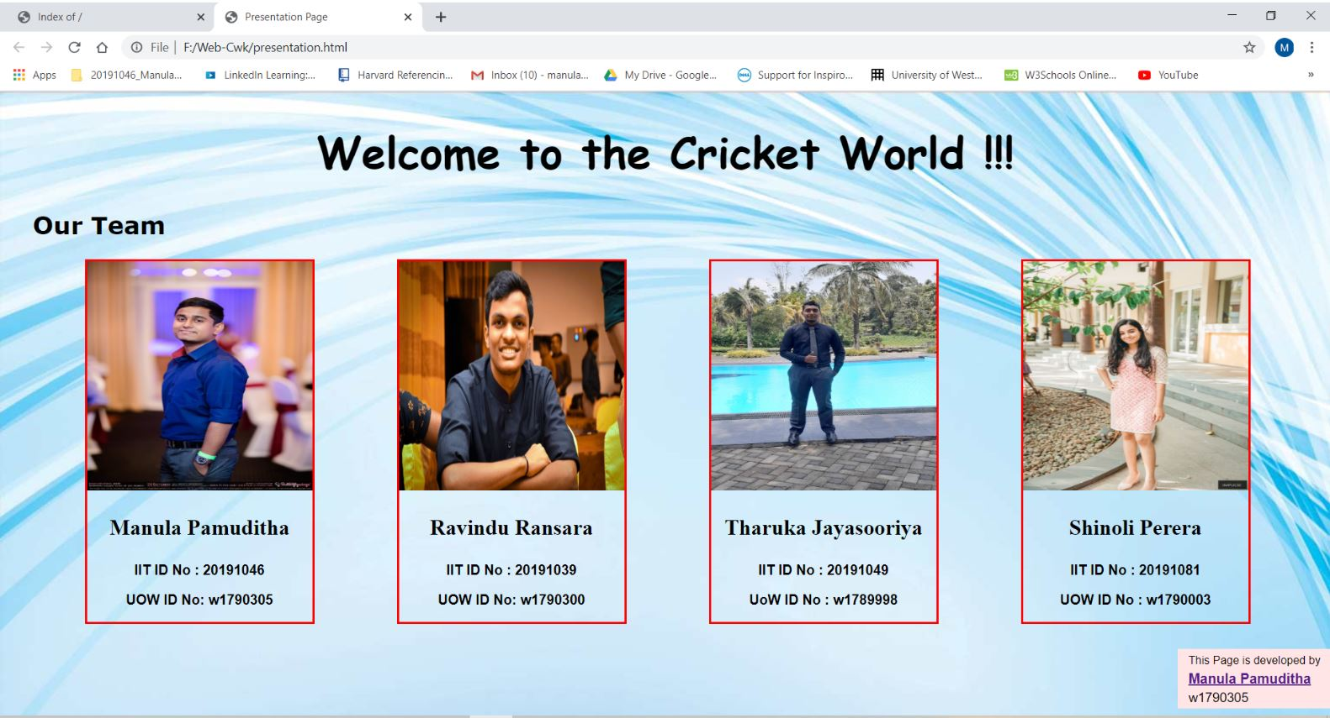

Filename : Shopping Page

Screenshots :

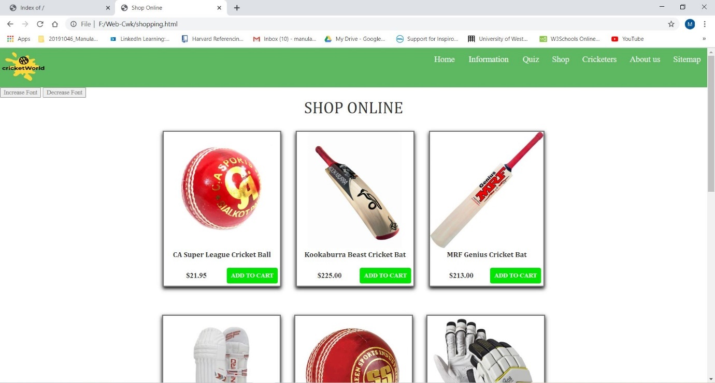

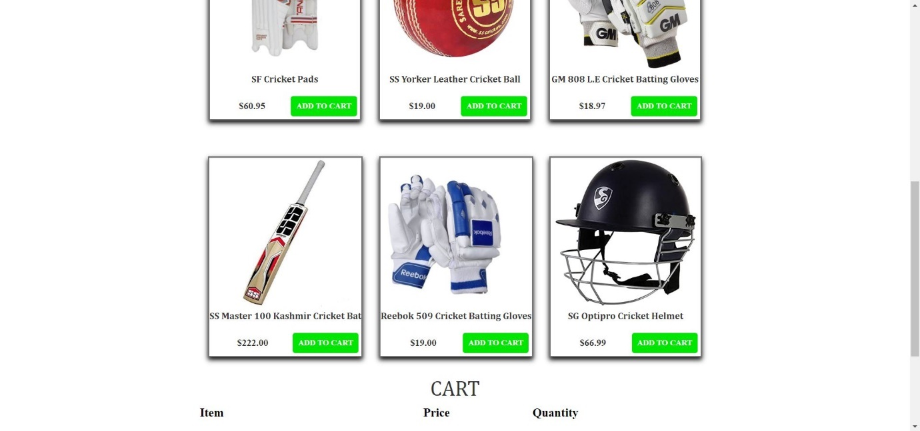

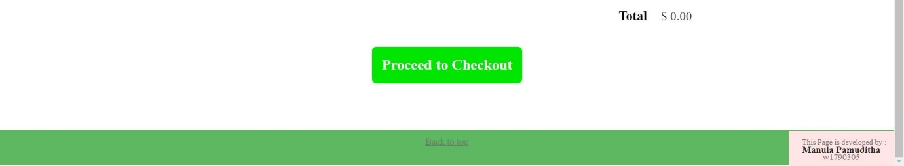

When Add to Cart button clicked :

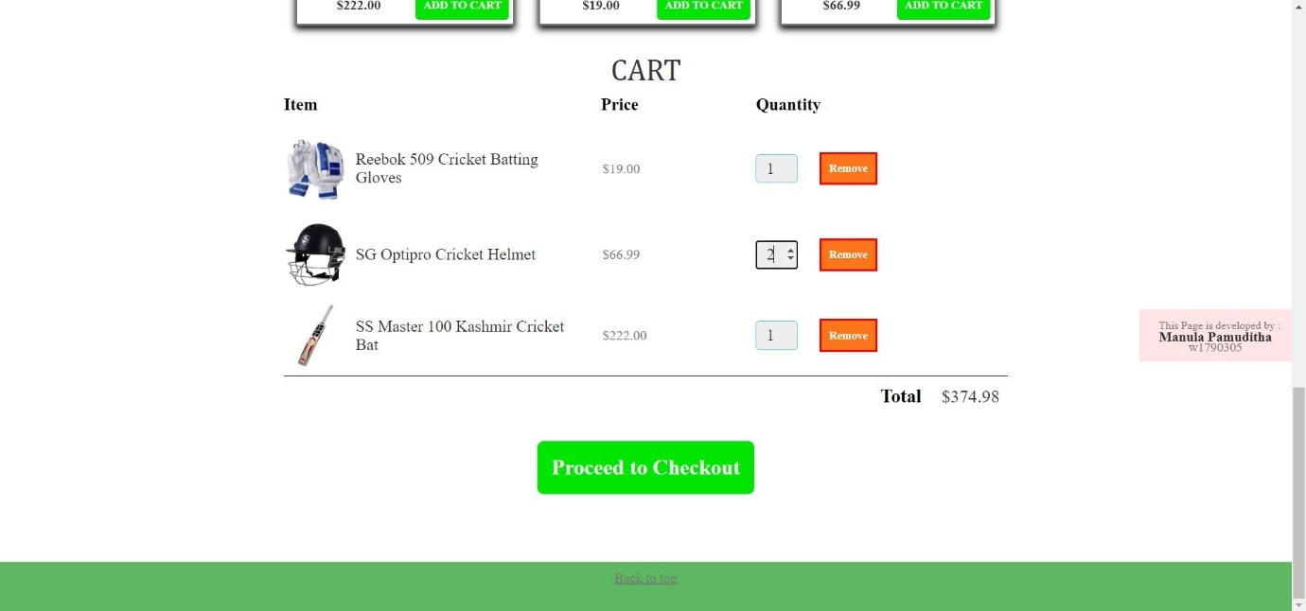

When Proceed to Checkout button clicked :

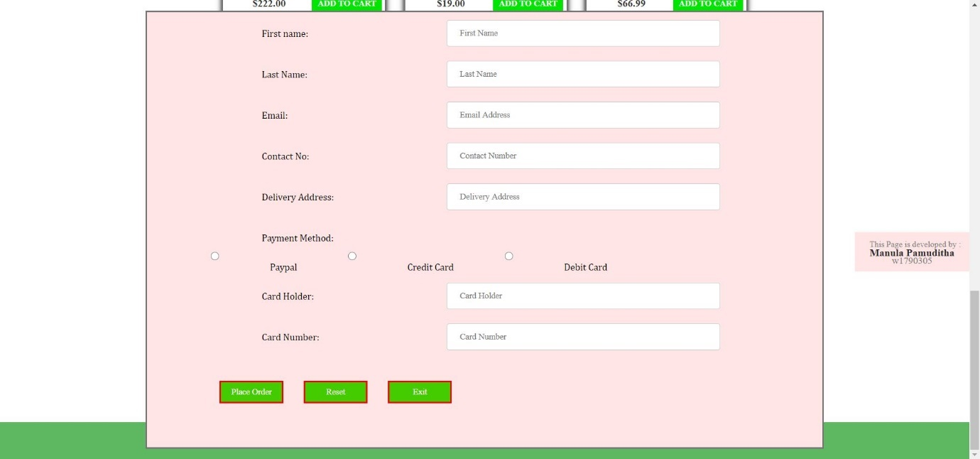

When Place Order button clicked :

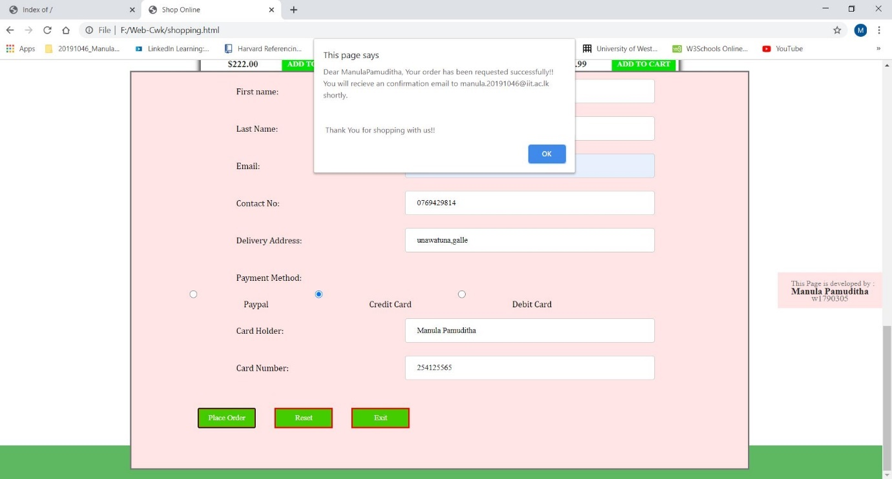

Filename : History of cricket(Information Page)

Screenshots :

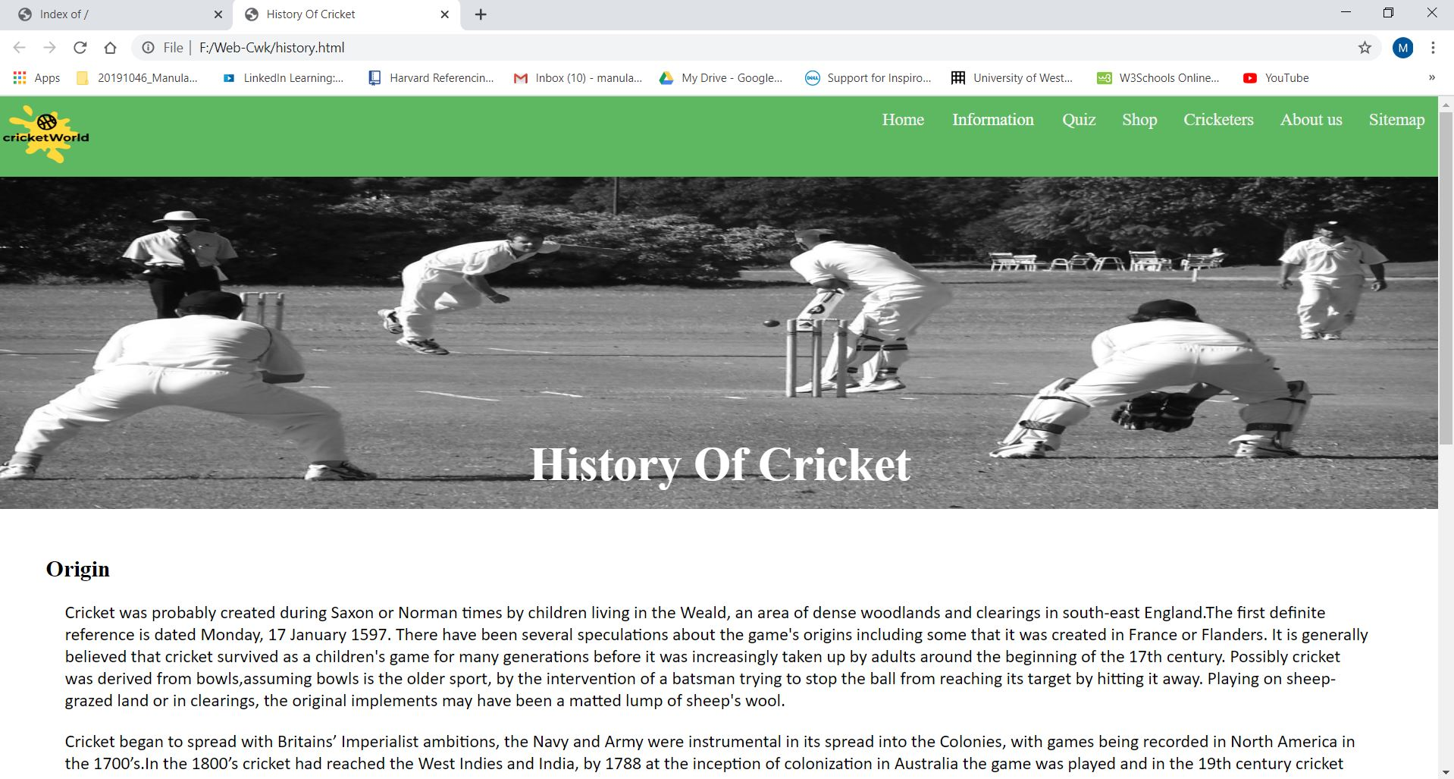

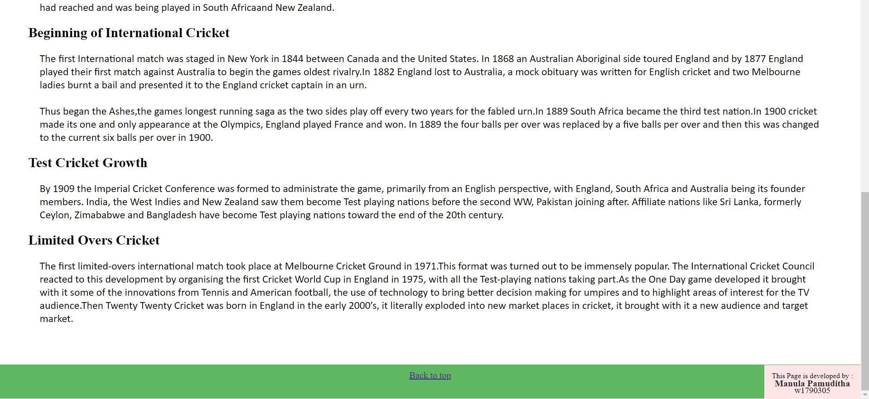

Filename : Developer Page

Screenshots :

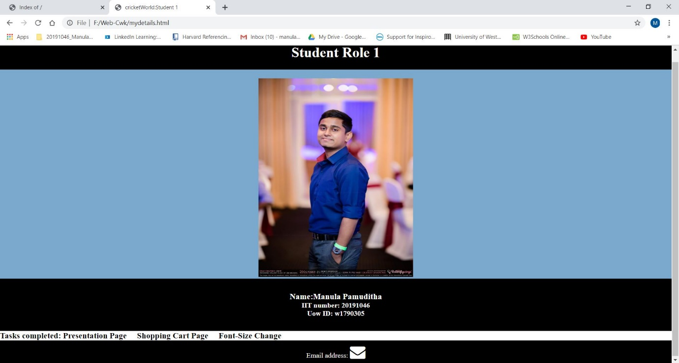

## Appendix C: Individual Statement

|  |  |  |  |
| --- | --- | --- | --- |
| Student Name: | Manula Haputhanthrie | Student Id: | 20191046 |
| State what tasks you carried out in the project. | | | |
| Presentation Page  Shopping Cart Page  Font-Size Changer  Information Page(History Of Cricket)  Developer Page containing my details | | | |
| State what you enjoyed and did not enjoy about teamwork. | | | |
| I enjoyed the teamwork we had between members and made good relationship with them.  I didn’t enjoyed the lack of communication happened in first days. | | | |
| State what you learnt about teamwork. | | | |
| It is very efficient to work as a team than working solo. Also to finish the project well, we have to keep a good communication. | | | |
| State what skills you gained/learnt from undertaking the project. | | | |
| How to work as a team properly  Positive Thinking | | | |
| State any strengths about yourself that emerged whilst undertaking the project. | | | |
| Quick Understanding | | | |
| State any weaknesses about yourself that emerged whilst undertaking the project. | | | |
| Managing time | | | |
| State how you would do things better if you were to undertake the project again. | | | |
| I will start the project as soon as possible because time really matters. Also I will do the project with better web designing skills. | | | |
| Additional general or project specific comments: | | | |
| I developed new skills in web designing by doing this project. | | | |
| Student Signature: | Manula | Date: | 23/07/2020 |